1. Factory pattern is creational pattern that hides/abstracts the complex details of object creation process.
2. 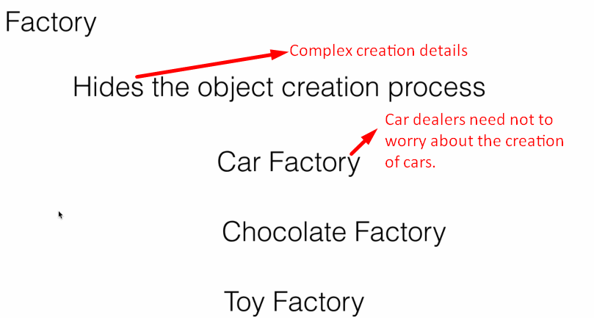
3. **Car Factory**:
   1. To manufacture cars.
   2. Car dealers need not to worry about the car creation process.
4. 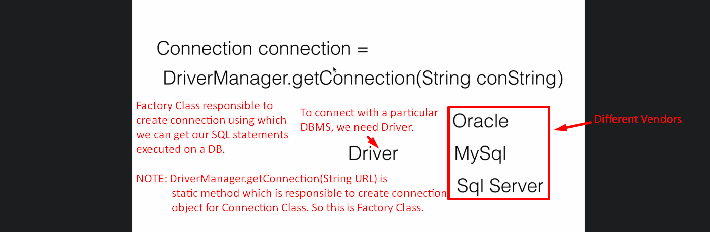
5. 